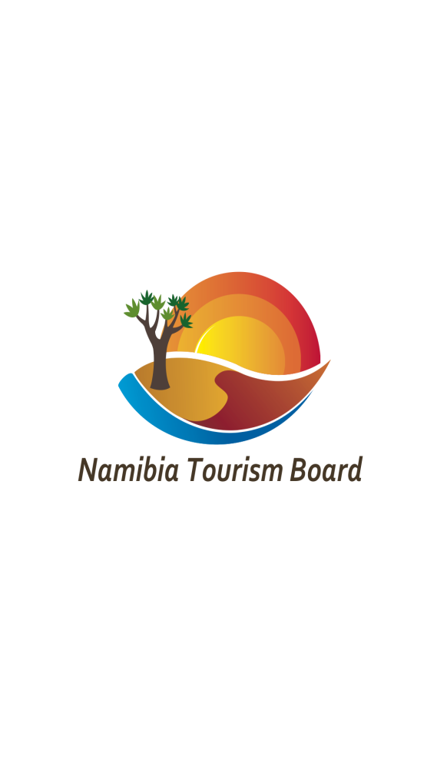

TRADE FAIR APPLICATION

IFTM TopResa 2025, International & French Travel Market.

Application Deadline: 30th May 2025
(First come first serve)

- BASIC PARTICIPATION FEE for the 3 days: EUR 3,930.00 + VAT

APPLICATION FEE: N$ 500

Event Name: | Event Date | Number of Operators/Partners
IFTM TopResa: Paris/France | 23rd-25th September | 5

  - The basic participation fee includes a branded table/counter, one power point, and access badges. Table setups will be done by the participants- therefore you are encouraged to take along your brochures/flyers, business cards & Laptops for presentation purposes.

  - The basic participation fee excludes, visa fees, airfares, travel insurance, hotel accommodation, local transportation, meals and customs clearance. Those and any likely expenses have to be borne by the participant in addition to the basic participation fee.

  - Marketing agents/companies or Destination Management Companies (DMC’s/DMO’s), who represent a whole range of individual accommodation establishments or regulated businesses, not belonging to the same group, have to pay the participation fee plus a surcharge of 20%. The same is applicable to any other business operator not required by law to register with NTB Associations.

  - Second or more representative (s) per company will pay an additional 10% of the participation fee per person.

.

- GENERAL COMPANY DETAILS

NAME OF COMPANY
(as registered with NTB)
POSTAL ADDRESS

TELEPHONE

COMPANY E-MAIL

INTERNET / WEBSITE

NTB REGISTRATION NUMBER

MEMBER OF TOURISM ASSOCIATION
(please specify)

- MARKETING PORTFOLIO

If owning or representing more than one accommodation establishment or other NTB registered business, please complete below section or attach a separate list:

NAME OF ESTABLISHMENT / BUSINESS | NTB REGISTRATION NUMBER(S)

- 1st COMPANY REPRESENTATIVE

NAME

DESIGNATION
E-MAIL

- 2nd COMPANY REPRESENTATIVE

Only when space is available, NTB will allow a 2nd representative

NAME
DESIGNATION
E-MAIL

- PAYMENT PROCEDURES

The Participation fee of N$ to be paid to Namibia Tourism Board – account details are

Account Name: Namibia Tourism Board

Account Number: 041 4639 8 6

Branch Number: 082372

Swift code: SBNMNANX

Account held at: Standard Bank Namibia
Private Bag 13177
Windhoek
Namibia

Reference no: Your NTB registration number plus IFTM 2025

Confirmation of participation will be accompanied by an invoice of 100% of the total participation fee to secure your space, which shall be non-refundable if decided not to participate any longer after space is confirmed on your behalf.

INCOMPLETE APPLICATIONS WILL NOT BE CONSIDERED

- DECLARATION

I HEREBY AGREE THAT THE CONTENT HEREIN ARE TRUE AND COMMIT OUR COMPANY TO FULL PAYMENT UPON CONFIRMATION OF PARTICIPATION BY THE NTB.

NAME OF COMPANY

SIGNATURE
DATE

Kindly register and completed application form per pdf file to the following person:

Marc Claydon: mclaydon@namibia-tourism.com

Web: www.visitnamibia.com.na

